**Homework Problems**: Now, calculate these matrices using R. Copy the R session showing your commands and results and paste into a Word document to submit to the classroom. All problems below can be completed using the information found in the prior sections of this document. If you have any questions, please post to the General Questions area of your classroom and your instructor or other students will be able to assist you. Feel free to extend your learning and practice additional matrix commands. Post any questions you have. (Hint: Remember to create the datasets as your first step and then perform the math operation.)

> install.packages("expm")

> library(expm)

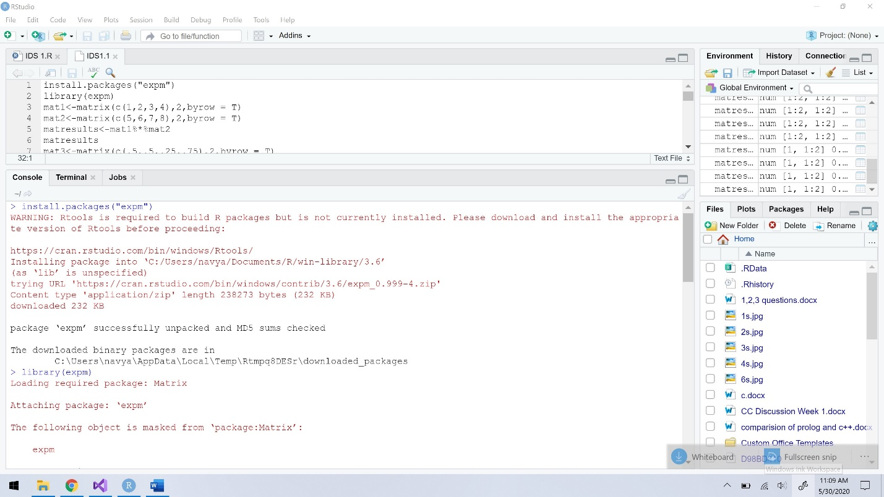

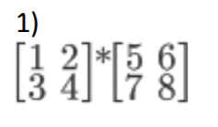

> mat1<-matrix(c(1,2,3,4),2,byrow = T)

> mat2<-matrix(c(5,6,7,8),2,byrow = T)

> matresults<-mat1%*%mat2

> matresults

[,1] [,2]

[1,] 19 22

[2,] 43 50

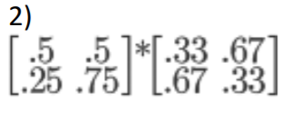

> mat3<-matrix(c(.5,.5,.25,.75),2,byrow = T)

> mat4<-matrix(c(.33,.67,.67,.33),2,byrow = T)

> matresults1<-mat3%*%mat4

> matresults1

[,1] [,2]

[1,] 0.500 0.500

[2,] 0.585 0.415

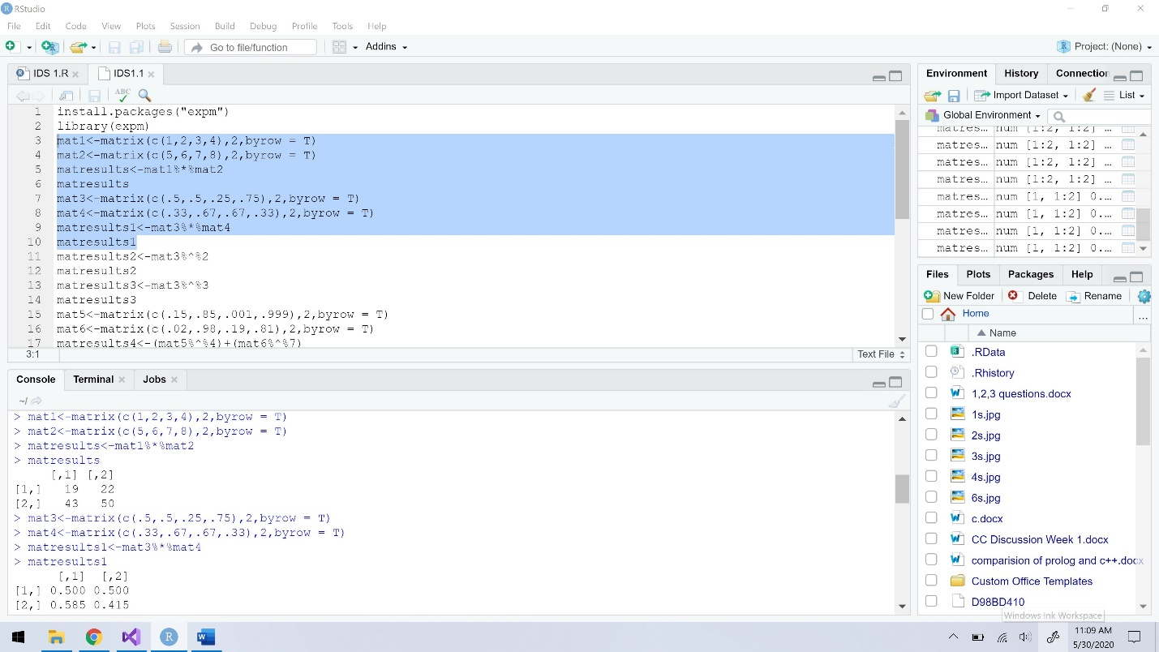

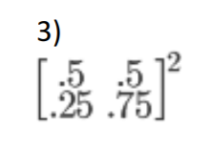

> matresults2<-mat3%^%2

> matresults2

[,1] [,2]

[1,] 0.3750 0.6250

[2,] 0.3125 0.6875

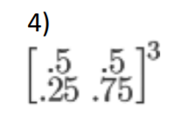

> matresults3<-mat3%^%3

> matresults3

[,1] [,2]

[1,] 0.343750 0.656250

[2,] 0.328125 0.671875

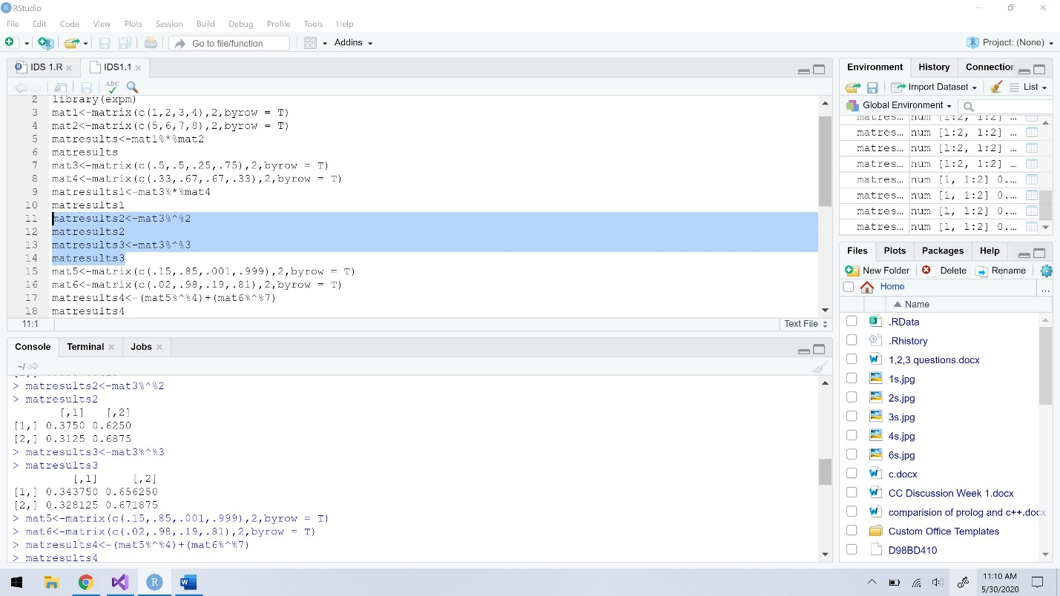

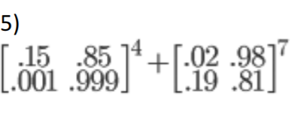

> mat5<-matrix(c(.15,.85,.001,.999),2,byrow = T)

> mat6<-matrix(c(.02,.98,.19,.81),2,byrow = T)

> matresults4<-(mat5%^%4)+(mat6%^%7)

> matresults4

[,1] [,2]

[1,] 0.1640571 1.835943

[2,] 0.1635683 1.836432

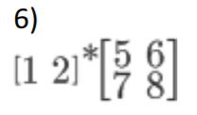

> mat6<-matrix(c(1,2),1,byrow = T)

> matresult5<-mat6%*%mat2

> matresult5

[,1] [,2]

[1,] 19 22

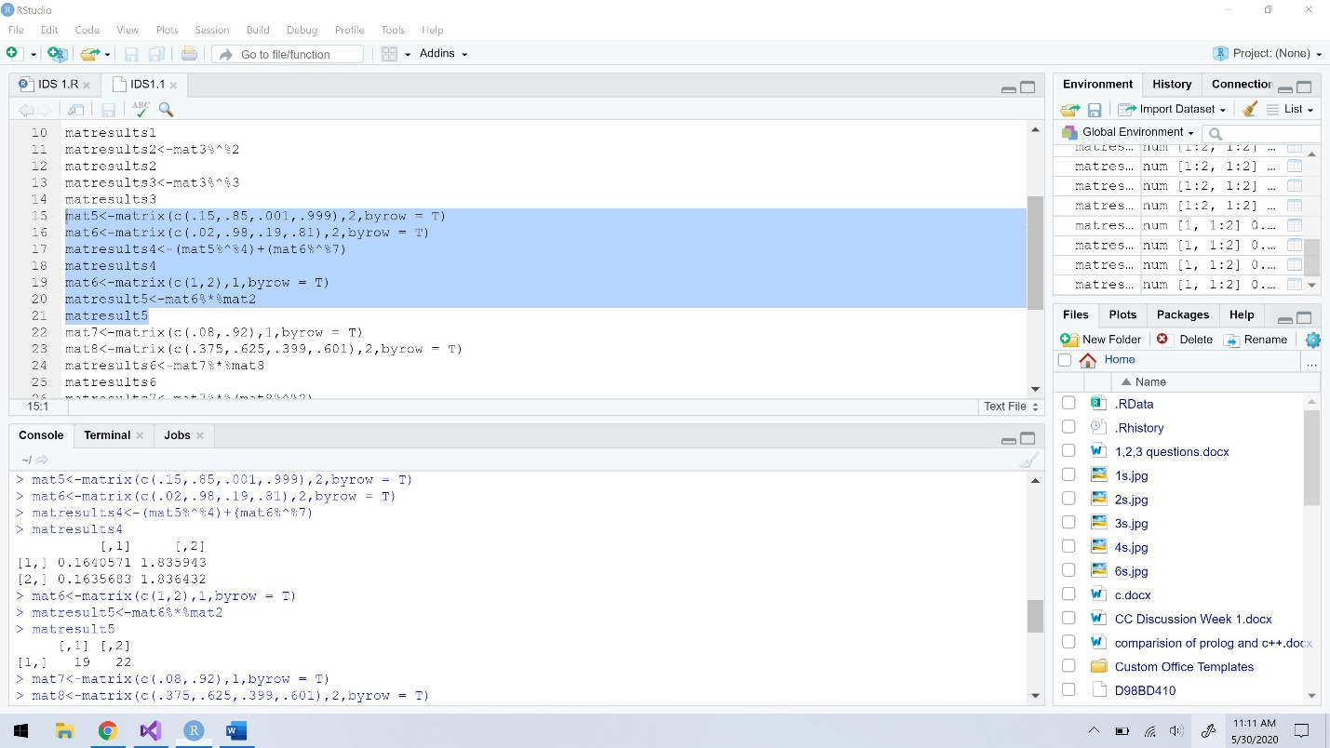

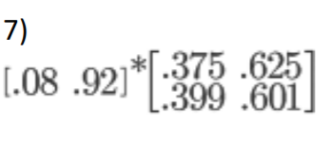

> mat7<-matrix(c(.08,.92),1,byrow = T)

> mat8<-matrix(c(.375,.625,.399,.601),2,byrow = T)

> matresults6<-mat7%*%mat8

> matresults6

[,1] [,2]

[1,] 0.39708 0.60292

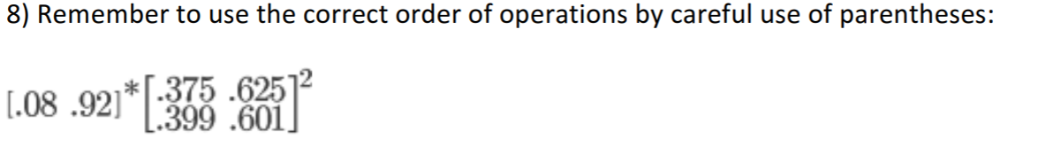

> matresults7<-mat7%*%(mat8%^%2)

> matresults7

[,1] [,2]

[1,] 0.3894701 0.6105299

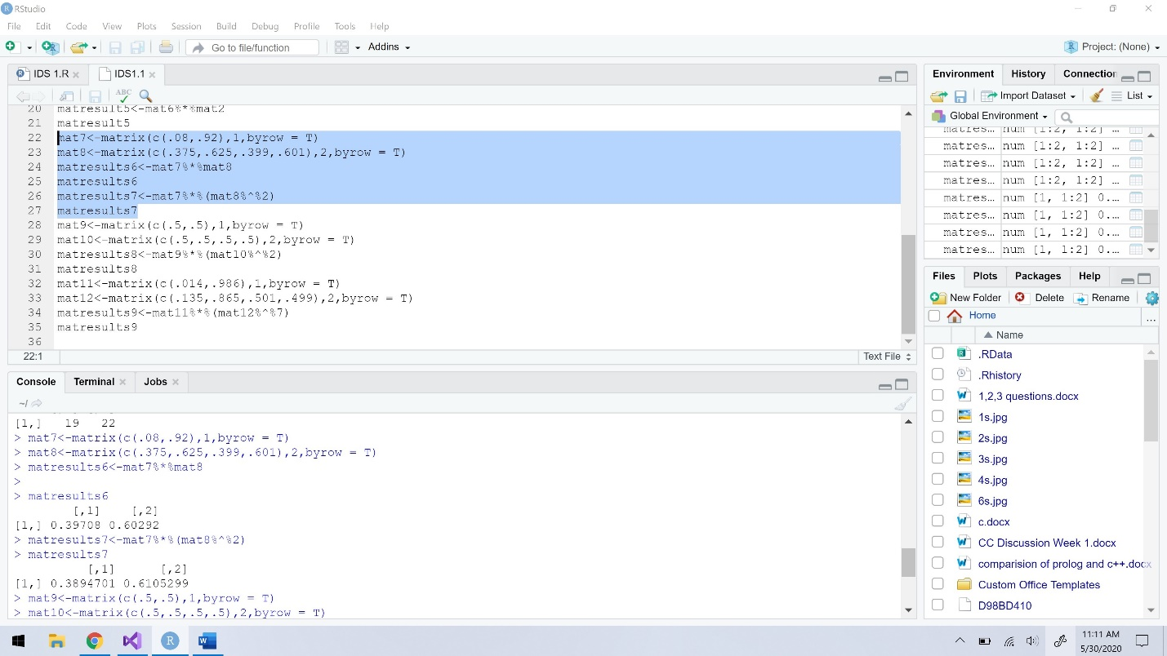

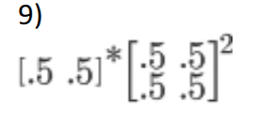

> mat9<-matrix(c(.5,.5),1,byrow = T)

> mat10<-matrix(c(.5,.5,.5,.5),2,byrow = T)

> matresults8<-mat9%*%(mat10%^%2)

> matresults8

[,1] [,2]

[1,] 0.5 0.5

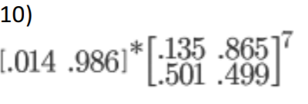

> mat11<-matrix(c(.014,.986),1,byrow = T)

> mat12<-matrix(c(.135,.865,.501,.499),2,byrow = T)

> matresults9<-mat11%*%(mat12%^%7)

> matresults9

[,1] [,2]

[1,] 0.3670746 0.6329254

